**Canny Edge Detection Write-Up**

When examining the differences between the three images and the differences between the thresholds that created them, I believe I caught on to a trend. It appears that as the difference of t1 and t0 gets smaller, the number of lines increases.

Threshold 1 (0-1)

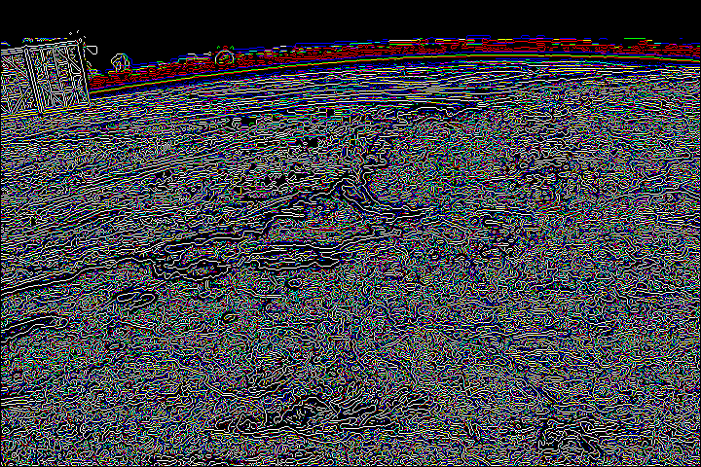

Threshold 2 (10-90)

Threshold 3 (50-80)